Melodrama
Luis Miguel García-Mainar (University of Zaragoza, Spain)

With origins in the novel and the theatre, melodrama appeared in late eighteenth-century Europe and reached maturity at the turn of the twentieth century. In the United States, the incipient film industry adopted it as a vehicle for suspense and action stories aimed at a mass audience. Melodrama featured a Manichaean world where unquestionably virtuous protagonists had to endure suffering and defend themselves from the advance of evil, in the form of utterly villanous antagonists. Of the same family as the biblical parable, it offered testimonies of moral struggle that have pervaded most commercial cinema across the world—in France, Italy, Mexico, the Middle East, and the various Indian industries—yet is best known through its Hollywood incarnation. Hollywood combined the melodrama with various types of action films but also developed a distinct version revolving around domestic conflict and sentimental plots. 1970s film criticism associated the term with films centered on women and family life, frequently containing a more or less open critique of dominant gender relations. Key examples of this type of melodrama are King Vidor’s Stella Dallas (1937), Douglas Sirk’s Written on the Wind (1956) or Vincente Minelli’s Some Came Running (1958). Excessive in form and emotions and subtly critical of social mores, it combined popular appeal and modernist stylization, and attracted auteurs striving after cultural respectability and commercial success.

Melodrama and Modernity
The term melodrama first referred to dramas in which the dialogue’s emotional content was enhanced by music. It resulted in a form of entertainment that combined music, dance, drama, and pantomime. Between 1880 and 1920 a more sensational, spectacularly staged melodrama, extremely popular in American and European popular theatre, was adapted into film serials. Both stage melodramas of this time and film serials were regarded low artistic forms that catered to the basic instincts of the masses by means of suspense and excess. They were products of and reflections on modernity, with its rapid urbanisation, new means of transport and communication, and emerging social structures and styles of intimacy. Melodrama then adopted its characteristic features: dramatic conflict between good and evil, stock characters (the hero, the heroine, the villain), a hyperbolic aesthetic, and an episodic swiftly moving plot (Neale 2000, 196). Some studies have explained it as an allegorical form, an attempt to unearth a hidden world of moral meaning—or “moral occult”—repressed by a society that had turned its back on religion after the Enlightenment and the French Revolution. In this view, melodrama was a fable about the inevitable conflict between good and evil; it offered guidance to cope with personal and social dilemmas in a world lacking ultimate moral guarantees (Brooks 1985, 51-60). Its operating mechanisms echo Freudian psychology, as melodrama works by displacing emotion and repressed meanings onto setting and costume, which are to be read as symptoms of the conflicts that beset characters (Elsaesser 1987, 58-60).

Two Strands of Film Melodrama
Melodrama has always been a diffuse, elusive concept that resists easy conceptualisation, partly because the term has been used to refer to different types of films and conventions at different times. To the mainstream American film industry, it meant stories that featured crime, violence, tension, moral Manichaeism, and suspense. This use reveals the connection between nineteenth-century melodrama and Hollywood’s genres of action and suspense—horror films, thrillers, Westerns, war films, and action-adventure pictures. In this strand of melodrama—called at times “action melodrama” (Walker 1982, 16-18)—helpless women are often threatened by men who seduce and abandon them, while male heroes are subject to the uncertainties of a troubled world. The broad spread of melodramatic gestures across a variety of films suggests that more than as a genre, melodrama may be seen as a narrative mode whose conventions underpin many genres. From this point of view, melodrama is one of the foundational cinematic modes of the United States, where films have traditionally exhibited morally charged conflicts with characters seeking to escape social constrictions (Williams). This notion of melodrama is illustrated by such classics as Way Down East (D.W. Griffith, 1920), but also by film noirs such as John Huston’s The Maltese Falcon (1941), gangster films such as Scarface (Howard Hawks, 1932), horror films such as Frankenstein (James Whale, 1931), or Westerns such as Stagecoach (John Ford, 1939).
However, melodrama has also come to mean emphasis on heightened emotionalism and sentimentality, usually in the context of the family. The family melodrama deals with the process by which characters adjust their social and sexual profiles to the strict confines of the home; it thus functions as safety valve for tensions and contradictions arising from sex, gender roles, and familial relations (Mulvey 1987, 75). Nicholas Ray’s Rebel Without a Cause (1955) or Vincente Minnelli’s The Cobweb (1955), Some Came Running (1958) and Home from the Hill (1960) are good examples of this formula. Related to this trend are the melodramas that overlap the category of the woman’s film, centred on the struggle of women to reconcile their sexuality and social ambitions with their roles as wives and mothers. This is probably the most popular meaning of the genre in the field of film studies, which has tended to identify melodrama with women and their concerns. Classic woman’s films would be Stella Dallas (King Vidor, 1937), Rebecca (Alfred Hitchcock, 1940), Mildred Pierce (Michael Curtiz, 1945), Secret Beyond the Door (Fritz Lang, 1947) and The Reckless Moment (Max Ophüls, 1949). Key in this strand of the genre was Douglas Sirk, a German director who moved to Hollywood in the 1930s to make a series of highly regarded melodramas in the 1950s. Magnificent Obsession (1954), All that Heaven Allows (1955), Written on the Wind (1957) and Imitation of Life (1959) used mise-en-scène (setting, costume and colour) in order to signal sexual or familial conflict, turning it into a trademark of the genre that would later be imitated by other filmmakers, such as German director Rainer W. Fassbinder during the 1970s (http://whitecitycinema.com/tag/all-that-heaven-allows/).

References and further reading
Brooks, P. (1985) ‘The Melodramatic Imagination’, in M. Landy (ed.) Imitations of Life: A Reader on Film and Television Melodrama, Detroit: Wayne State UP.
Doane, M. A. (1987) The Desire to Desire: The Woman’s Film of the 1940s, Basingstoke: Macmillan.
Elsaesser, T. (1987) ‘Tales of Sound and Fury: Observations on the Family Melodrama’, in Gledhill (ed.). 43-69.
Gledhill, C. (ed.) (1987) Home Is Where the Heart Is: Studies in Melodrama and the Woman’s Film, London: BFI.
Klinger, B. (1994) Melodrama and Meaning: History, Culture, and the Films of Douglas Sirk, Bloomington: Indiana UP.
Mercer, J. and M. Shingler (2004) Melodrama: Genre, Style and Sensibility, London: Wallflower P.
Mulvey (1987) ‘Notes on Sirk and Melodrama’, in Gledhill. 75-79.
Neale, S. (2000) ‘Melodrama and the Woman’s Film, Genre and Hollywood, London: Routledge. 179-204.
Singer, B. (2001) Melodrama and Modernity: Early Sensational Cinema and Its Contexts, New York: Columbia UP.
Walker, M. (1982) ‘Melodrama and the American Cinema’, Movie, 19/30: 2-38.
Williams, L. (2001) Playing the Race Card: Melodramas of Black and White from Uncle Tom to O.J. Simpsom, Princeton: Princeton UP.

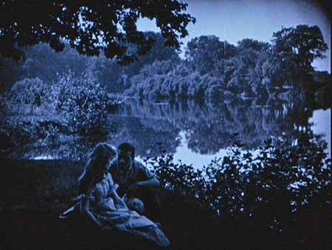
D.W. Griffith’s Way Down East (1920)
http://brightlightsfilm.com/63/63_images/63griffith1.jpg

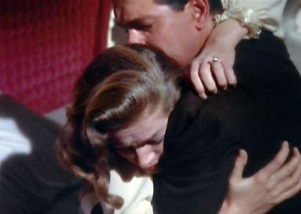
Lauren Bacall and Rock Hudson in Douglas Sirk’s Written on the Wind (1957)
http://www.movingimagesource.us/images/articles/Written-on-the-Wind_2-20080812-093909-medium.jpg

